Common Garden Pests

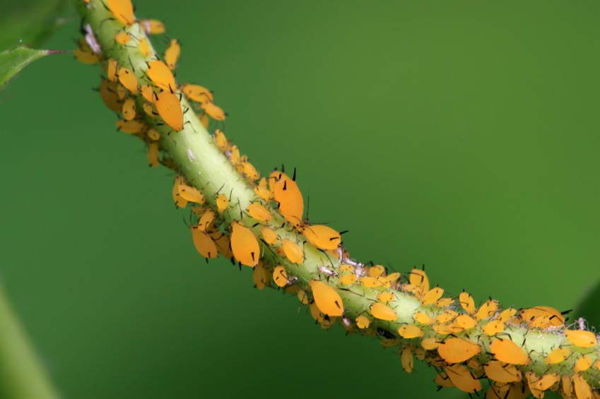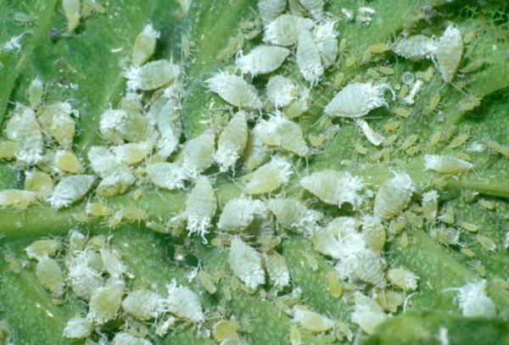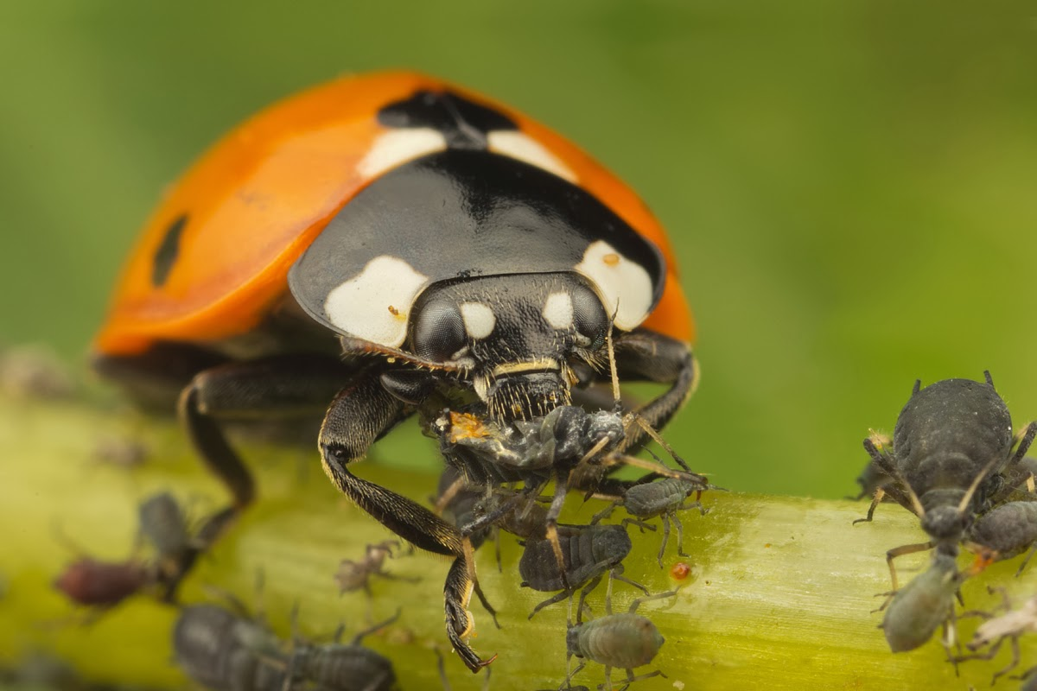
Aphids: Curled, mottled leaves on tender new growth, may be a sign of aphids. They usually form colonies and can severely damage or stunt plant growth if they get out of control. They are a favorite food of a number of garden predators, however, so I generally leave them alone. The presence of a lot of aphids will eventually attract predators to your garden, who will also help control other pests. If the infestation gets bad and you don’t notice any predators, you can blast the aphids with the nozzle of a hose. Most of them have very weak walking abilities and won’t be able to make it from the ground back onto your plants. Horticultural soap is generally very effective against aphids.

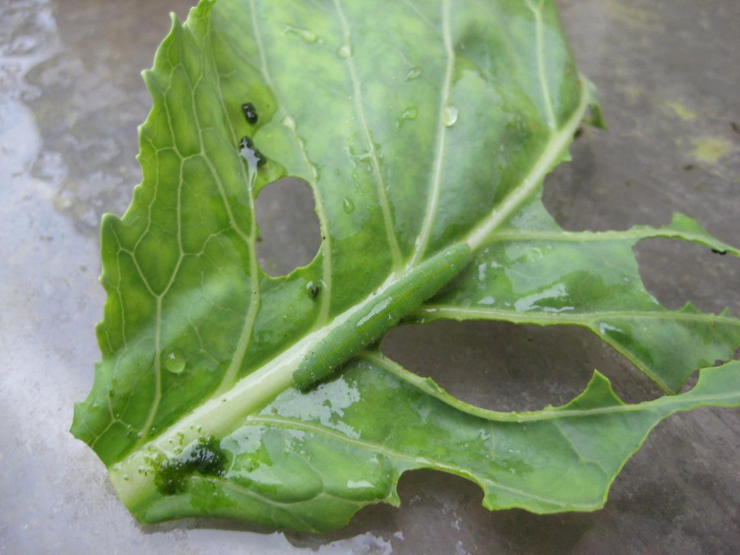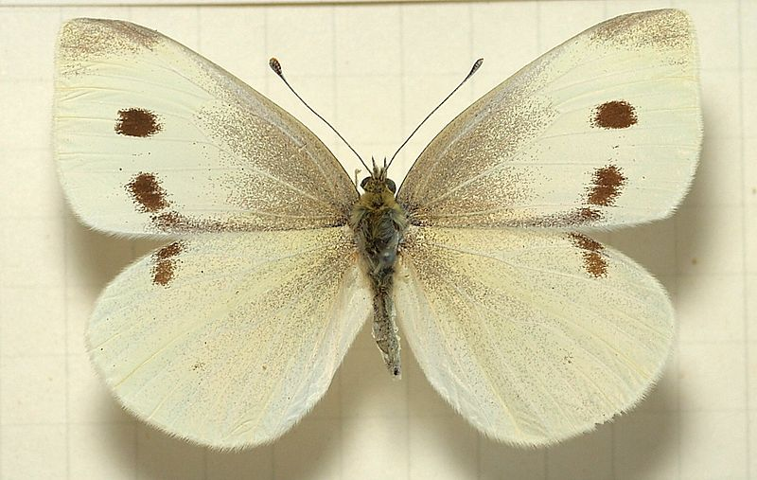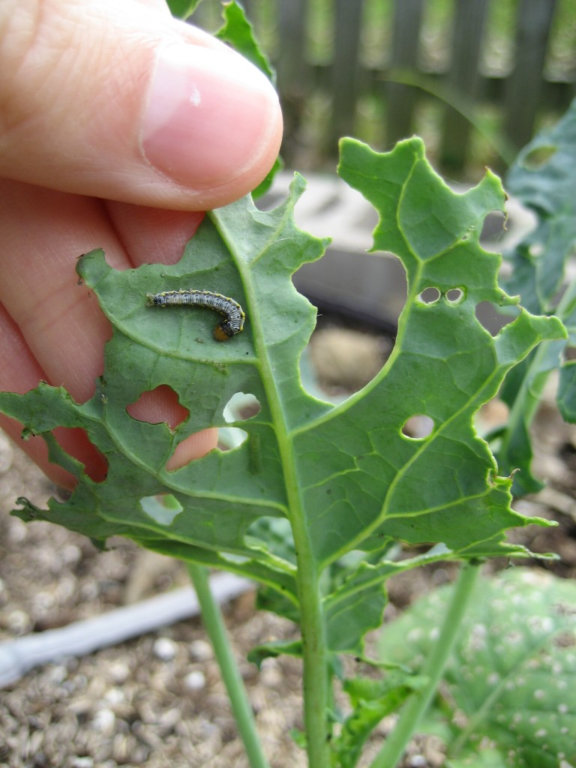
Cabbage worms: can encompass a number of different species of caterpillars that munch on brassicas. The most common signs are leaves with large holes and chunks taken out of the edges and trails of “frass” (aka poop) left behind. Small caterpillars and tiny ovoid eggs can be found on the undersides of leaves, while larger caterpillars will often venture to the topside to eat. Many species are light green and can be hard to spot against the leaves. The adults are visible as white moths fluttering over your garden. Check your plants regularly and hand pick off light infestations. Alternate spraying leaves with Bt and Spinosad every other week to control cabbage worms.
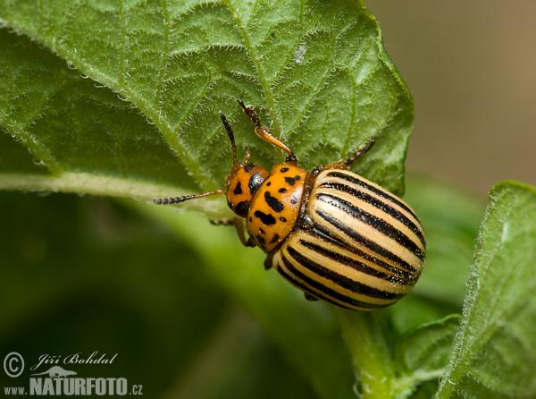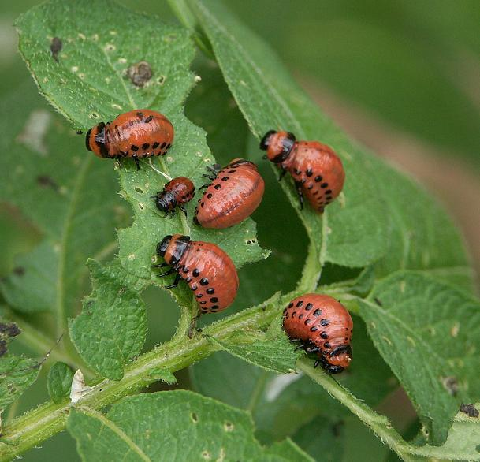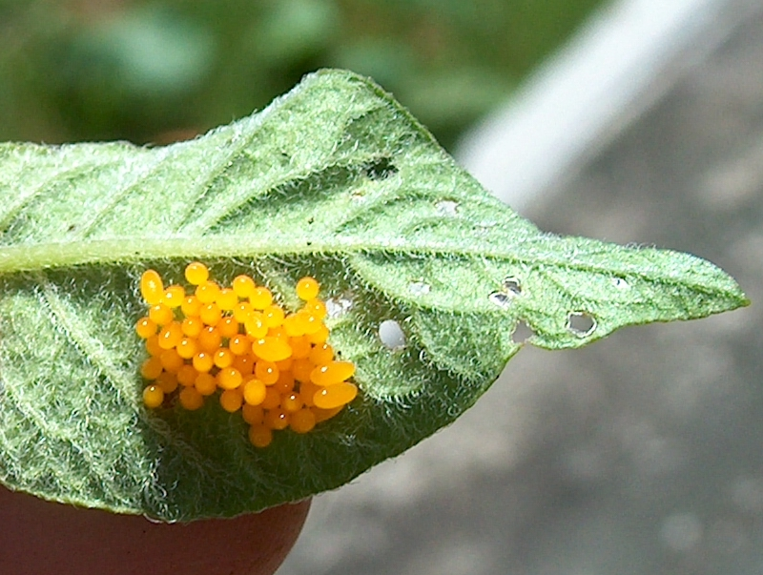
Colorado Potato Beetles: Most often found on potato foliage, but also known to eat eggplant, tomato and pepper leaves. Adults have striking black and yellow stripes, but it’s the reddish larvae that do the most damage to leaves. Eggs can be seen as orange clusters on the underside of leaves. Left unchecked, they can defoliate your plants and severely impact harvests of potatoes. They are easy to spot and remove by hand. Overuse of pesticides has made many resistant to chemicals. Planting flowers (buckwheat especially) around potatoes will help attract natural predators and thick mulch around the plants can help confuse beetles looking for plants from the ground. Use spinosad as a last resort under heavy infestations and continue handpicking.

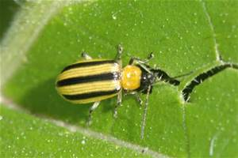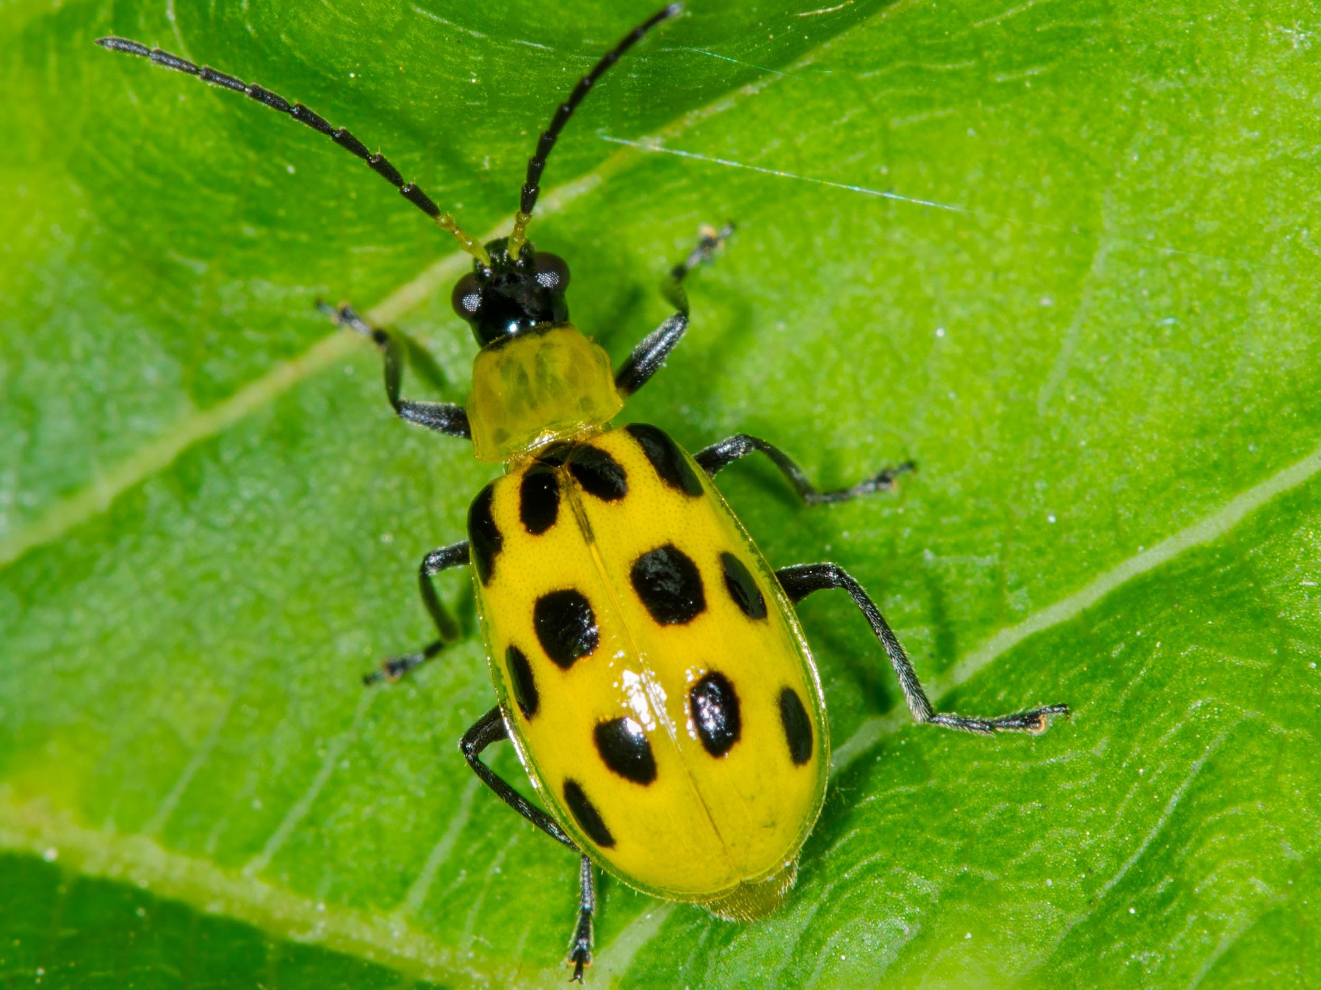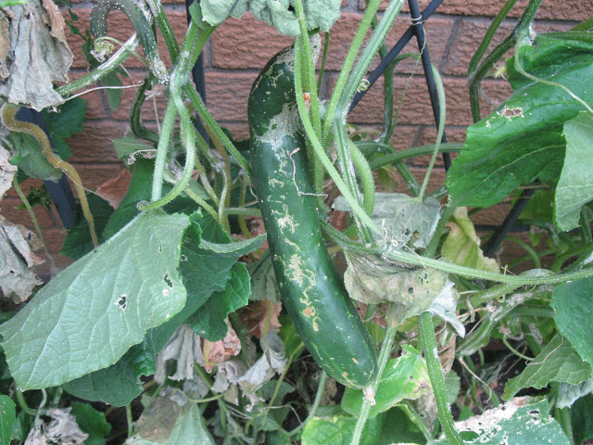
Cucumber Beetles: There are two major types of cucumber beetles: spotted and striped. Both are yellow, with either three black stripes or lines of black spots down their backs. Not only do they feed on plants (potentially killing seedlings) but they also transmit diseases like bacterial wilt. Bacterial wilt can kill plants in a matter of days. They lay eggs at the base of plants and larvae will feed on roots, also weakening plants. Row cover is the best way to control the beetles. Avoid planting cucurbits immediately in the spring, so beetle populations pass your garden by in search of food. Then leave plants covered until 7-10 days after the first flowers appear. Again, by delaying, you’ll avoid the second generation of beetles. Most cucumbers require insects for pollination, so you do need to uncover them. “Parthenocarpic” varieties do not need to be pollinated and will produce fruit under full, season long cover. Check catalog descriptions to find these varieties. Sticky traps, aluminum foil around the base of plants, and spraying the leaves with Surround can also be effective. Check the Mother Earth News website for more info on preventative measures.

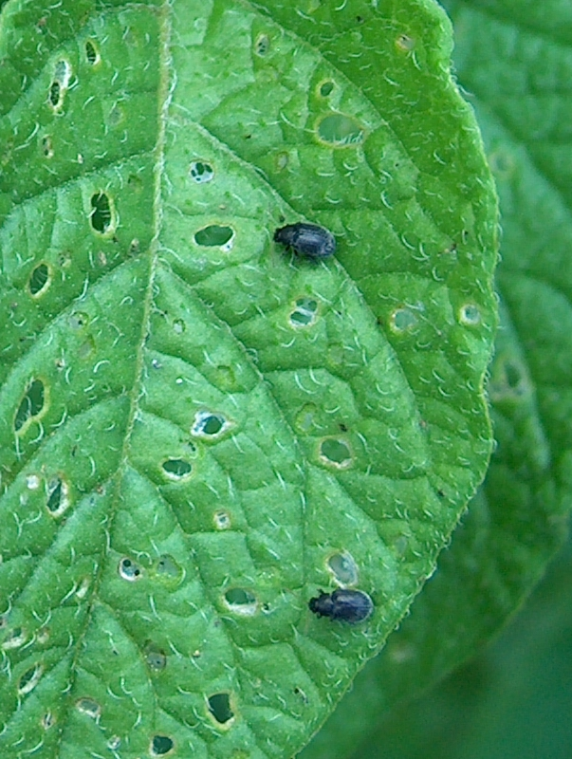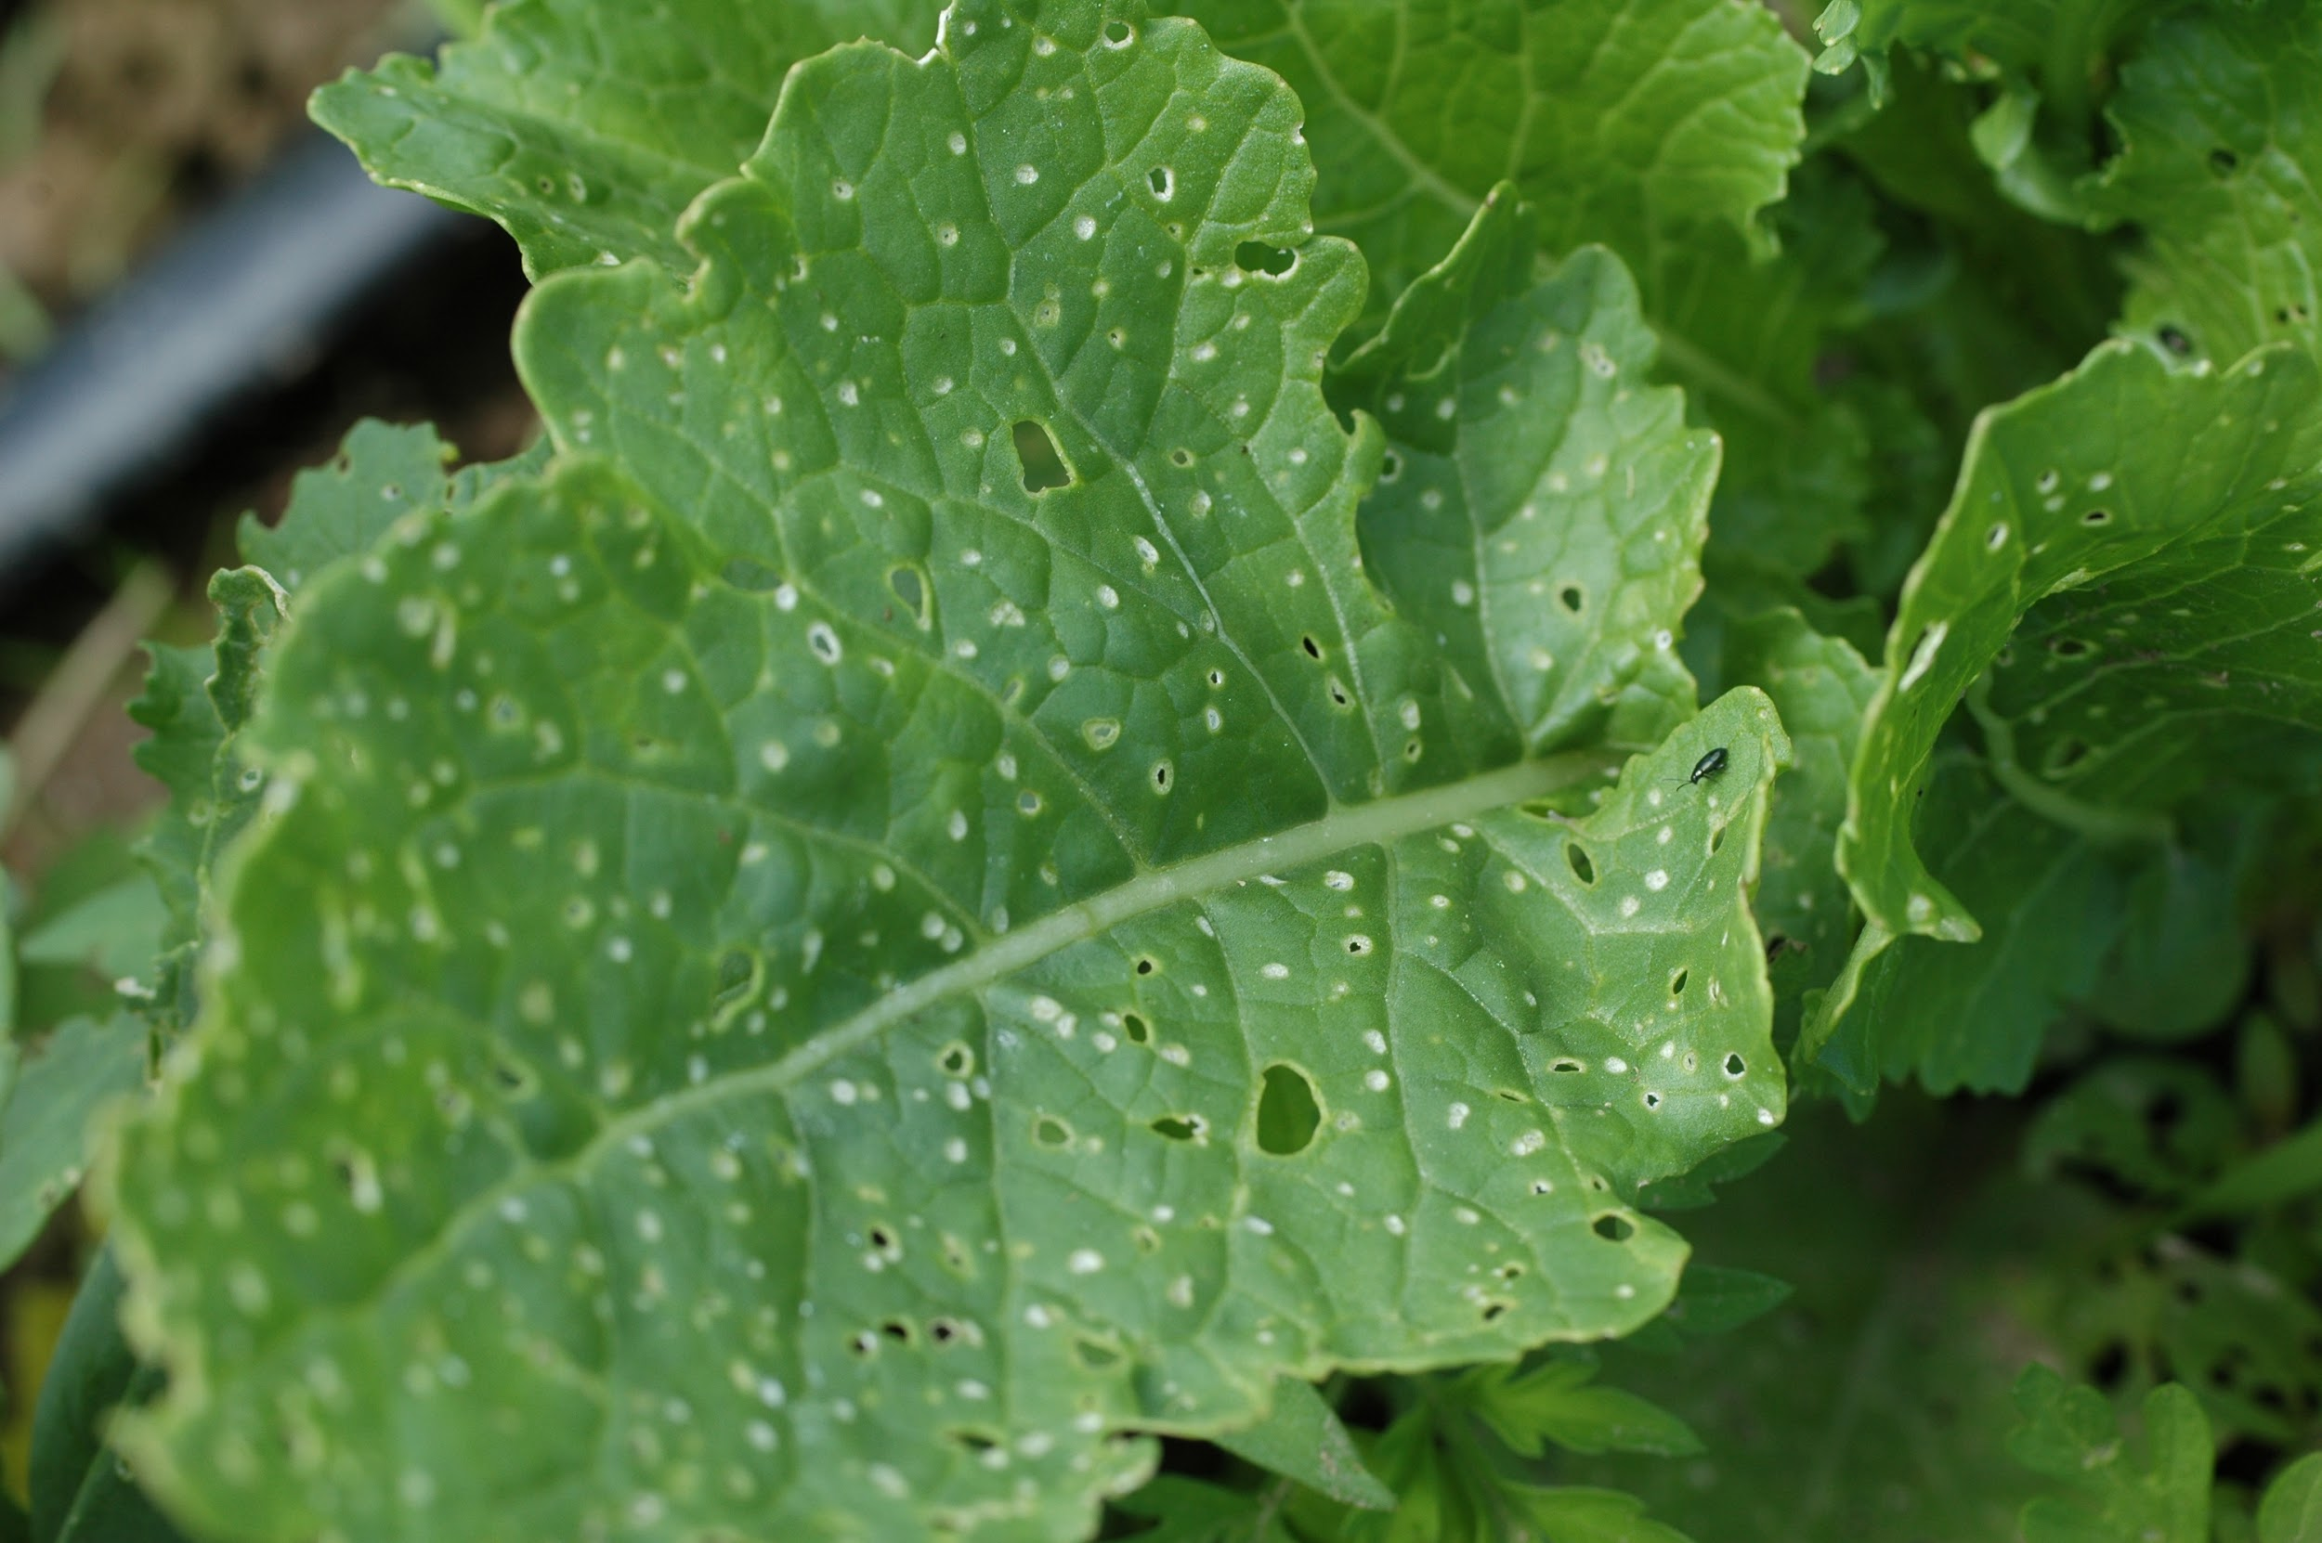
Flea Beetles: Damage appears as tiny shotgun holes in leaves. The beetles themselves are really, really tiny and you often don’t see them before they leap off the plant at your approach. They are especially fond of tender, young plants, so you can use row cover on susceptible crops until plants mature and are not so tender and delicious, . They overwinter in the soil and lay eggs in the soil near host plants. Crop rotation can help move plants away from overwintered populations. Tilling and hoeing the ground can also bring eggs and larvae up for predators to eat. Use insect barrier cloth (Agribon+ 15 is a brand name) on any crop that doesn’t need insect pollination (eggplant, cabbage, kale, chard, arugula, onions, etc.). Surround (a type of sprayable kaolin clay) may be a good deterrent.

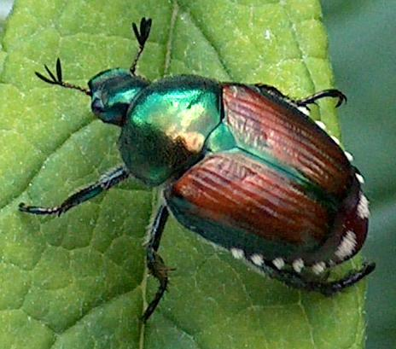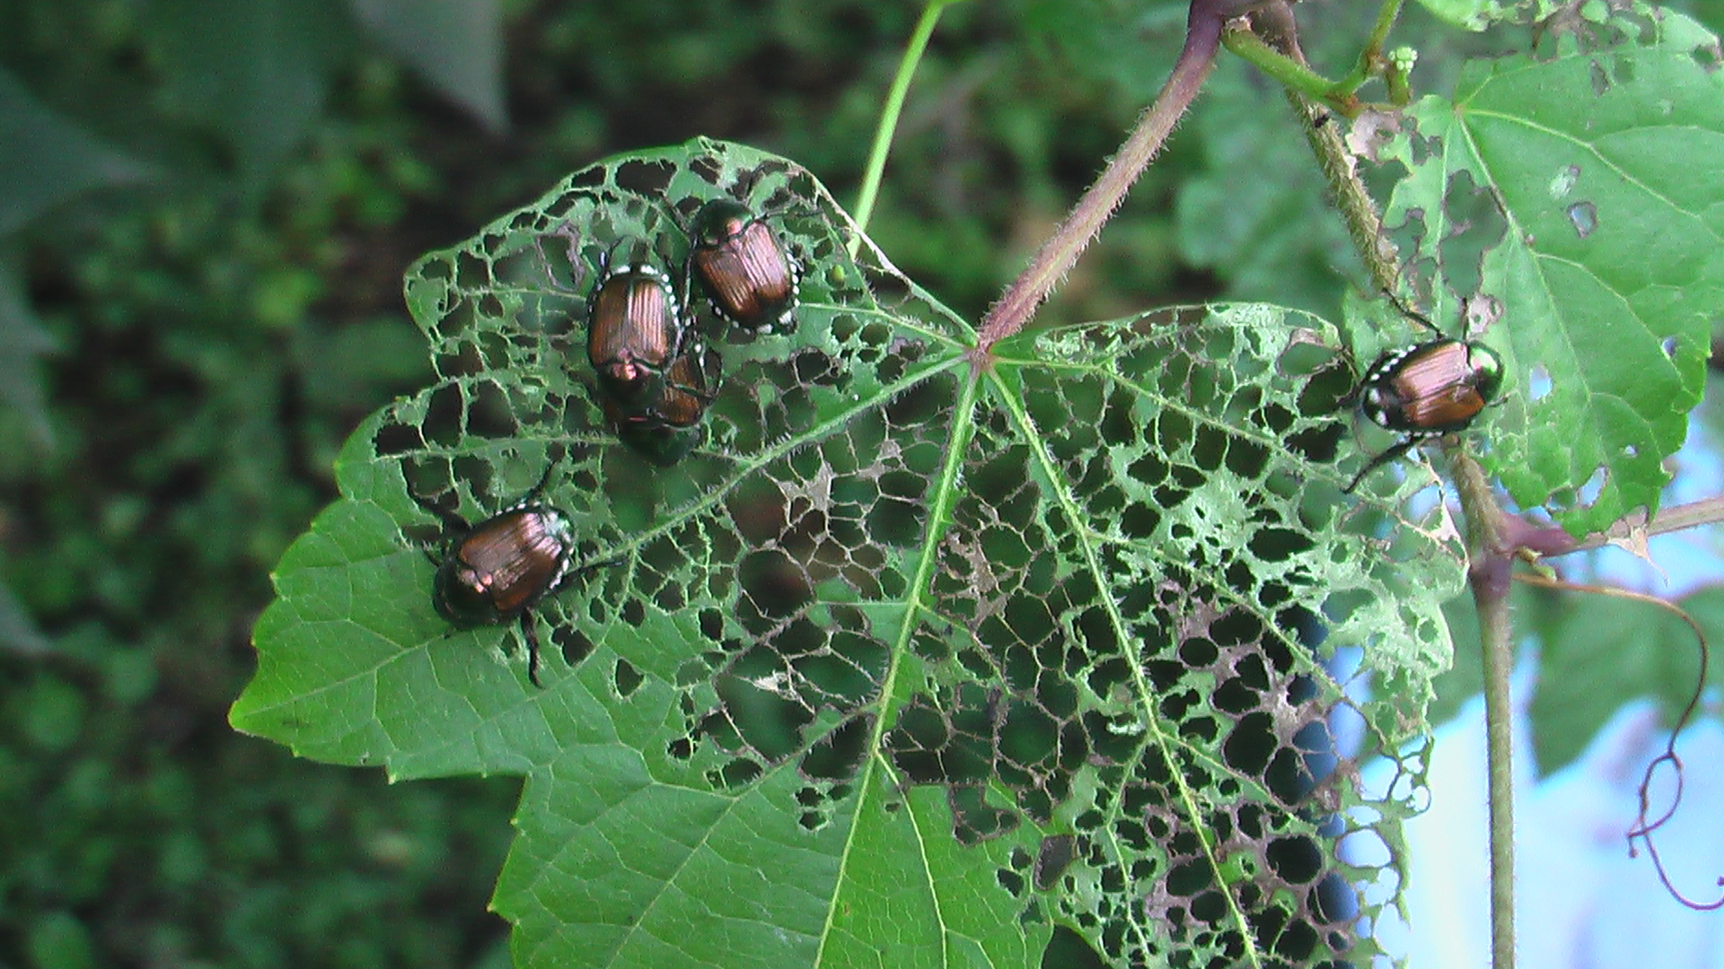
Japanese beetles: This invasive beetle will typically appear in mid-summer. It especially loves roses, but is happy munching on well over 300 other types of plants. They have a metallic copper shell on their backs and are easy to spot. When you find one, you usually find a lot, because they send out pheromone signals when they find a good food source. Row cover and hand picking can be effective. They overwinter in your lawn as grubs and one of the best controls is to spread Milky Spore Disease powder on your lawns. This microbe only attacks Japanese beetle grubs and will live for up to 20 years after one application in early fall. Avoid using traps near your garden, as they often attract more beetles than would be there naturally.

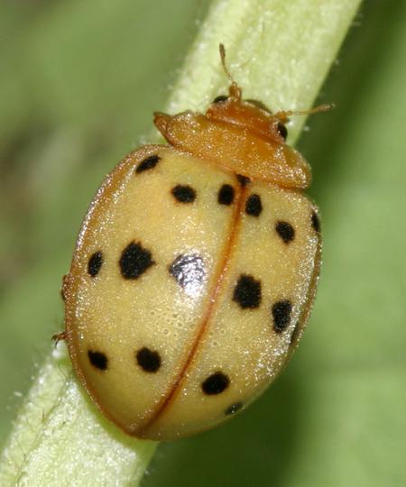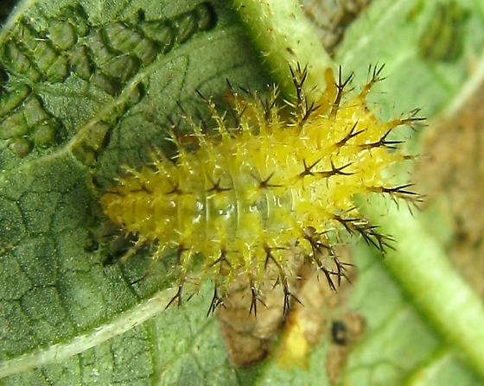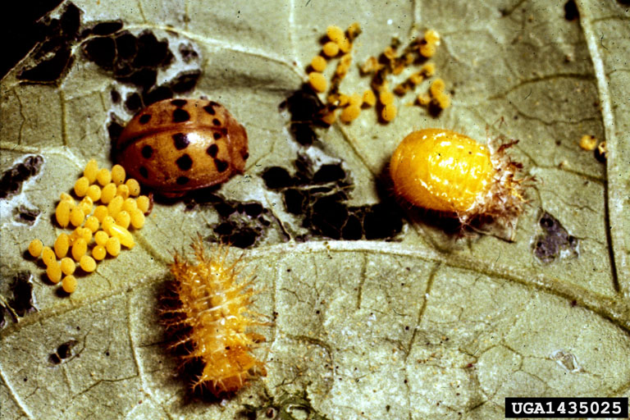
Mexican bean beetles: They look like large, copper colored ladybugs. The larvae are compact, yellow, soft-bodied things that can be found on both sides of leaves. Yellow clusters of eggs can be found on the underside of leaves They scrape the soft tissue off the leaves, leaving them looking skeletonized. If allowed to go out of control, they can defoliate plants and a bad infestation one year will lead to a bad one in the following year. There are not good organic pesticides that work on bean beetles. Hand picking is your best option. Check for the eggs on the underside of leaves, and once identified, be prepared to pick over plants daily. Plant lots of flowers around your garden to encourage beneficial predators to help in the cause. There’s anecdotal evidence that interplanting beans and potatoes helps avoid pests for both. Surround may be a good deterrent and Pyrethrum can be used for severe infestations.

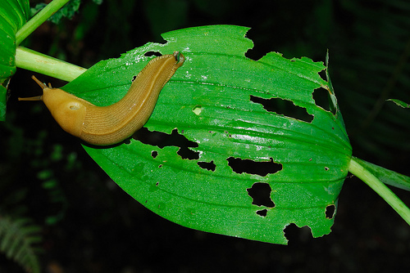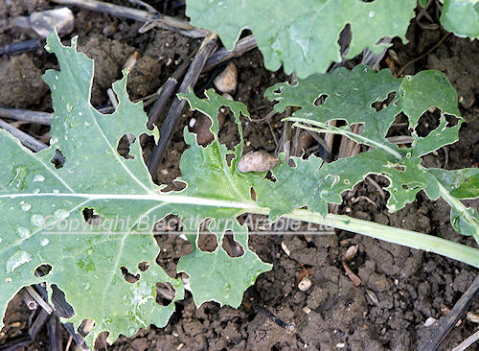
Slugs: Slugs mainly feed at night but they can come out on rainy overcast days. Slugs primarily damage leaves, but can take chunks out of fruits and soft vegetables. Heavy mulching, while generally beneficial, is a favorite home of slugs. The damage can range from light cosmetic to full defoliation, and can destroy young, tender seedlings as they rise up from the soil. Check online for different kinds of slug traps and use handpicking to keep populations down. Diatomaceous earth and iron phosphate slug bait are both effective against slugs.

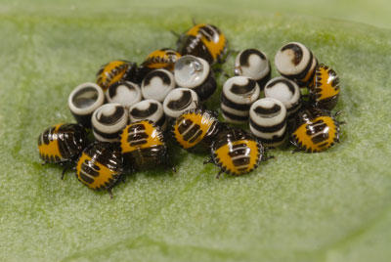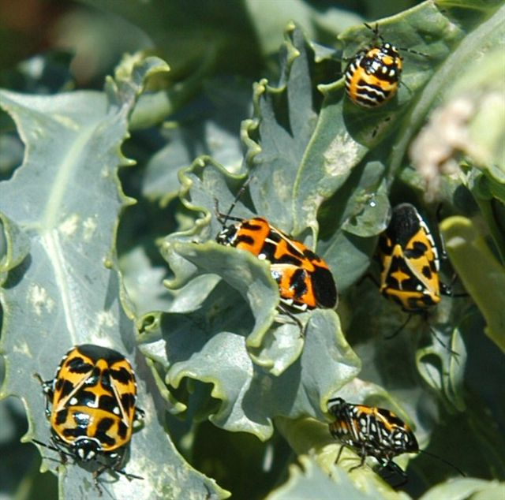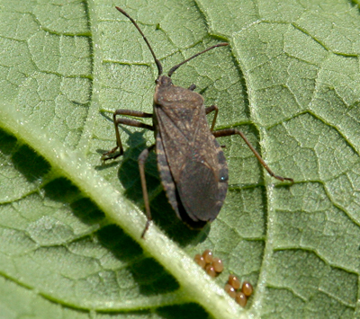
Stink bugs (Harlequin and Squash bugs): Stink bugs encompass a wide variety of both garden pests and garden protectors. The two I deal with the most are Harlequin bugs on brassicas and Squash bugs on cucurbits. They have a proboscis that sucks leaves dry and can cause severe cosmetic damage and defoliation to leaves and damage fruit. The harlequin bugs are bright orange with black spots that lay clusters of black and white eggs on the undersides of leaves. The squash bugs are grey and not as noticeable on the leaves, but the eggs are bright bronze clusters found on the undersides of leaves. There are not any good organic pesticides that work on these bugs. Your best options are to leave plants under light row cover to create a physical barrier against the bugs or to check your plants daily and handpick any adults, nymphs and eggs that you find. Also, squash need insect pollination, so you will have to uncover them when they start to flower. Some stink bugs are predatory and will kill and suck the juices out of other stink bugs. Learn what the bad pests look like and don’t just indiscriminately kill stink bugs.

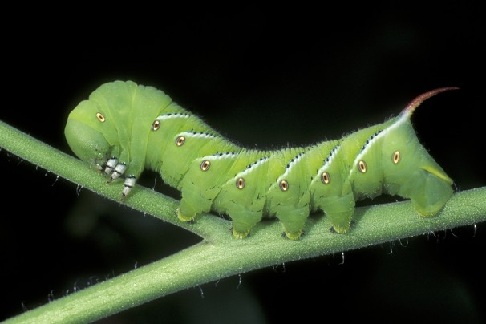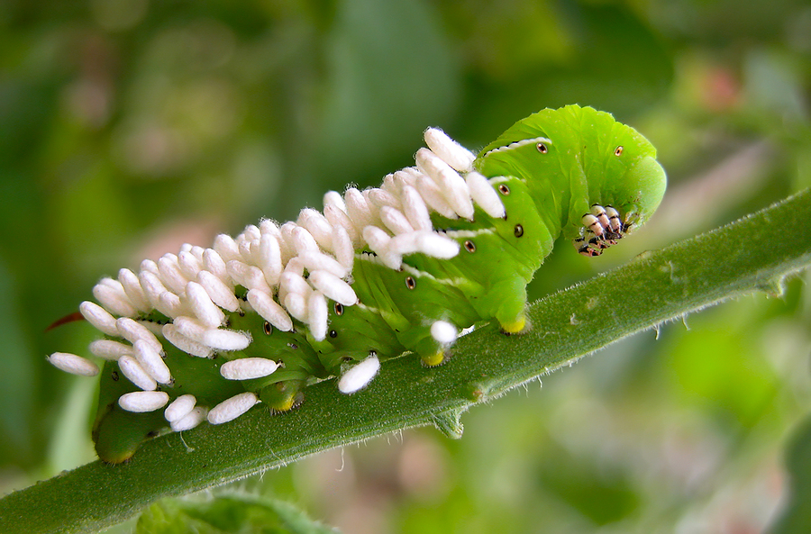
Tomato Hornworms: These guys are green caterpillars that blend in very well with the tomato leaves. You will likely see the damage they cause first, then their frass (poop) and then hunt around a bit before finding the worm itself. If you find a caterpillar with strange white sacks sticking out of it, leave it alone. It’s been parasitized by a special wasp and those egg sacks will soon hatch, devouring the worm, and then going on to start the process over again with other caterpillars in your garden. If no egg sacks are attached, hand picking, Bt or spinosad are effective controls.

Check out Mother Earth News website section called Organic Pest Control Series: Common Garden Pests for more information.

Learn to identify these bugs! Don’t go around killing or spraying just because you find any random bug in your garden. 90% of the insects you see on your plants or flying around are harmless and may even be highly beneficial. If you can identify the problem bugs, deal with them as selectively as possible. You actually want to encourage insects to be in your garden, because most do offer benefits, including eating your pest bugs.

